1. Write a program in c to print all permutations of a given strings of a pointer.

#include <stdio.h>

#include <string.h>

void swap (char *x, char *y)

{

char temp;

temp = *x;

*x = *y;

*y = temp;

}

void permute(char *a, int i, int n)

{

int j;

if (i == n)

printf("%s\n", a);

else {

for (j = i; j <= n; j++)

{

swap((a + i), (a + j));

permute(a, i + 1, n);

swap((a + i), (a + j));

}

}

}

int main()

{

char a[20];

int n;

printf("Enter a string: ");

scanf("%s", a);

n = strlen(a);

printf("Permutaions:\n");

permute(a, 0, n - 1);

getchar();

return 0;

}

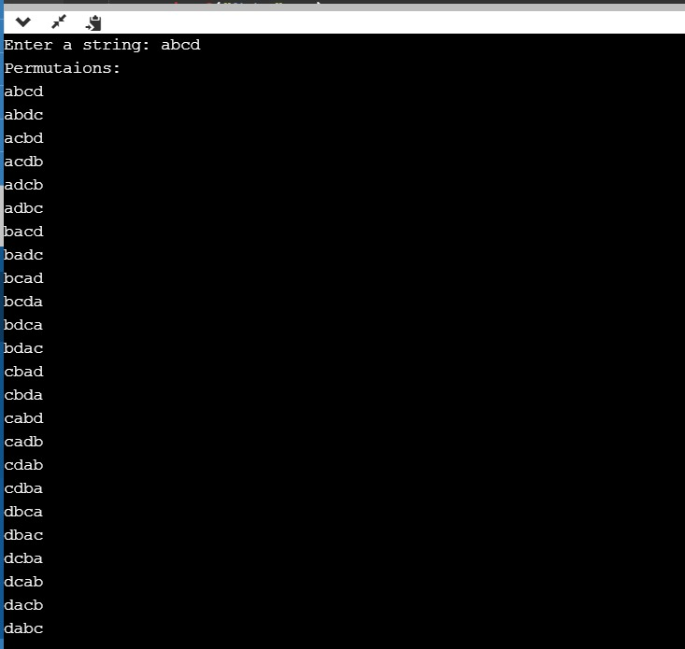

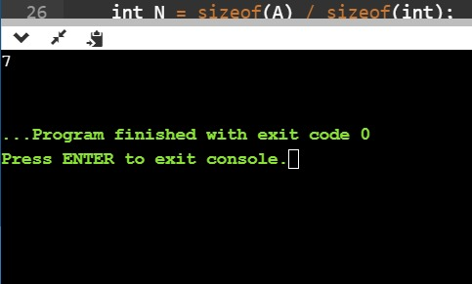

1. This is a Python Program to read a number n and print the number of digits in it

#include <bits/stdc++.h>

using namespace std;

void cntArray(int A[], int N)

{

int result = 0;

for (int i = 0; i < N; i++) {

result++;

int current_value = A[i];

for (int j = i + 1; j < N; j++) {

if (A[j] == current_value) {

result++;

}

}

}

cout << result << endl;

}

int main()

{

int A[] = { 1, 2, 1, 5, 2 };

int N = sizeof(A) / sizeof(int);

cntArray(A, N);

return 0;

}

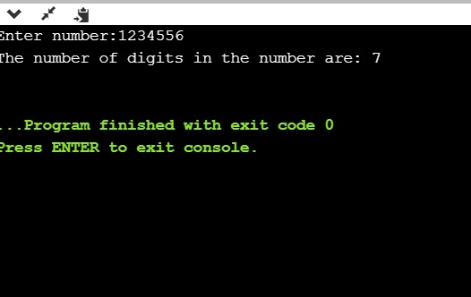

1. This is a Python Program to Check if a Number is a Palindrome

n=int(input("Enter number:"))

temp=n

rev=0

while(n>0):

dig=n%10

rev=rev*10+dig

n=n//10

if(temp==rev):

print("The number is a palindrome!")

else:

print("The number isn't a palindrome!")

